Jenkins & Docker

Docker + Jenkins + SSH - I

* Let’s create a new docker container with an SSH service so that we can connect to it from our current container.
* Create a Dockerfile: We will create our own image. From that image we will create our container.
  + Create a folder called centos7
  + Use vi to create the ***Dockerfile***
    - Use centos to create the image
    - Create a user with password
    - Create a home folder and ssh
    - Give rights to write with ***chmod***

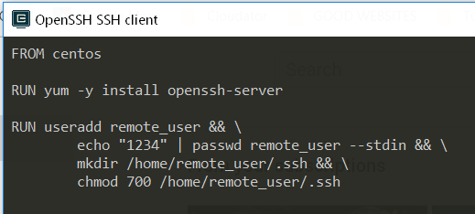

* We need to create a public/private ssh key pair
* In current folder centos, type

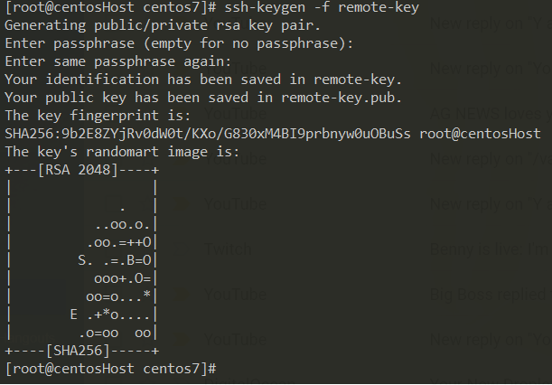

* Two keys. One public and one private.

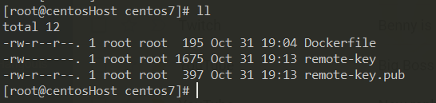

* Now update your Dockerfile
  + Add copy the current public key in this machine into the ssh folder of the remote docker container that we are creating
  + We start the service ssh

